MCG2101 – Intro Design of MCG Systems

Deliverable 5
Group 13

Names:
Haneen Barghouti
Lara Al Nakeeb
Emma Cochran
Linh Nguyen
Toshio Woo

Table of Contents
1. Progress Report 3
1.1. Locomotion 3
1.2. Sampling Mechanism 4
1.3. Buoyancy System 6
1.4. Structure and Wear Resistance 8
1.5. Stability System 10
1.6. Assembly 12
2. References 13
3. Appendix 14

List of Figures:

Figure 1 Full Klann Mechanism 3
Figure 2. Updated sampling mechanism section view hand sketch 4
Figure 3. Screw and cylinder in SolidWorks 5
Figure 4. Variable buoyancy system sketch highlighting the rotational to linear motion 6
Figure 5. Variable buoyancy system CAD 6
Figure 6. Crab Shell and Claws Sketch 9
Figure 7. Crab Shell and Claws Design in SolidWorks 9
Figure 8. Sketch of elliptical friction foot pad 11
Figure 9. Section and front view of footpad design in SolidWorks 11
Figure 10. Crab Assembly in SolidWorks 12
Figure 11. Locomotion Gantt Chart 14
Figure 12. Sampling Mechanism Gantt Chart 14
Figure 13. Buoyancy Gantt Chart 15
Figure 14. Frame Gantt Chart 15
Figure 15. Stability Gantt Chart 16

Progress Report

Locomotion

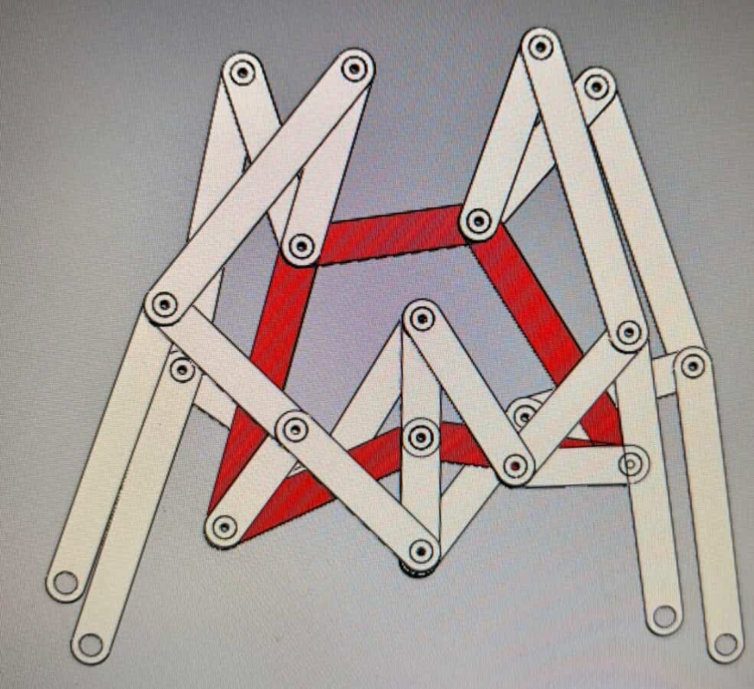
Figure 1 Full Klann Mechanism

The major progress for this deliverable was a completion of the full four-legged Klann Linkage. With this completed, the mechanism can be combined with the frame to determine restrictions on space usage and frame dimensions. In order to give the mechanism more modularity, the dimensions were set to global variables so that changes could easily be made and visualized.
The main feedback for the locomotion mechanism was to determine the driving conditions and a way to turn the crab. To drive the crab, a 716-403 – 16mm Brushless Motor will be used. Its small size and torque output of 0.3Nm makes it a good option to move the legs [1]. This motor will be connected along the central shaft in the mechanism and will allow the linkage to function. To rotate the crab, a variable gear ratio across the front and back legs will be used to vary the walking speeds in the front and back; when the front legs move faster, the crab will move rotate towards the back legs and vice versa.
The next steps for this system are to model the casing for the legs in SolidWorks, design the variable gearbox in SolidWorks, and fully integrate the legs into the frame.

1.2. Sampling Mechanism
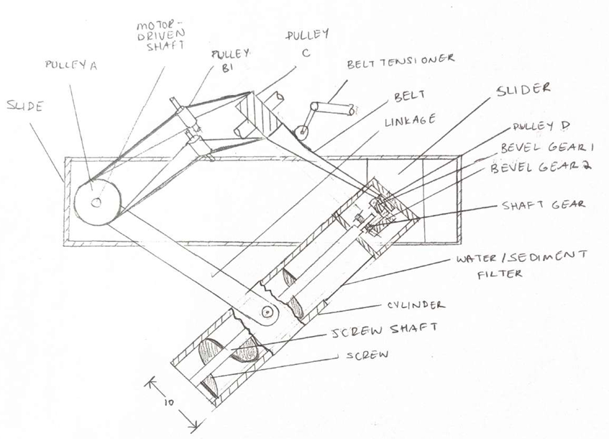

Figure 2. Updated sampling mechanism section view hand sketch

Last week, the team received feedback from the professor to minimize motors in the design in order to save space and simplify the mechanisms. To address the feedback, parts of the sampling mechanism were redesigned. Originally, there were two motors, one to drive the linkage and another to turn the screw in the cylinder. In the updated design, the motor in the cylinder was replaced with a belt drive system. In this design, the single motor for raising and lowering the arm will also have a pulley attached to the shaft. This pulley has a belt attached that goes over the rollers, allowing them to twist and connect to Pulley C. On the same shaft as pulley C, another belt, will connect to the gear system within the cylinder. A belt tensioner will be used to keep this second belt taut as the cylinder rises and lowers. Within the gearbox of the cylinder, the belt will turn a shaft with a bevel gear. This bevel gear will mesh with a smaller bevel gear, which in turn meshes with another even smaller bevel gear. This will allow the screw to turn at a higher speed than the motor driven shaft will lower the arm into the ground, at the cost of lower torque. The rest of the design remains the same with a Scott-Russel linkage, Archimedes screw, and sediment filter. Additionally, SolidWorks parts were created for the screw and cylinder, as seen in Figure 2 below with images of the screw and section view of the cylinder. Next steps include looking into a quarter twist drive system to eliminate the needs for rollers and simplify the system, identifying exact gear ratio and torque requirements, and continuing to model parts in SolidWorks.
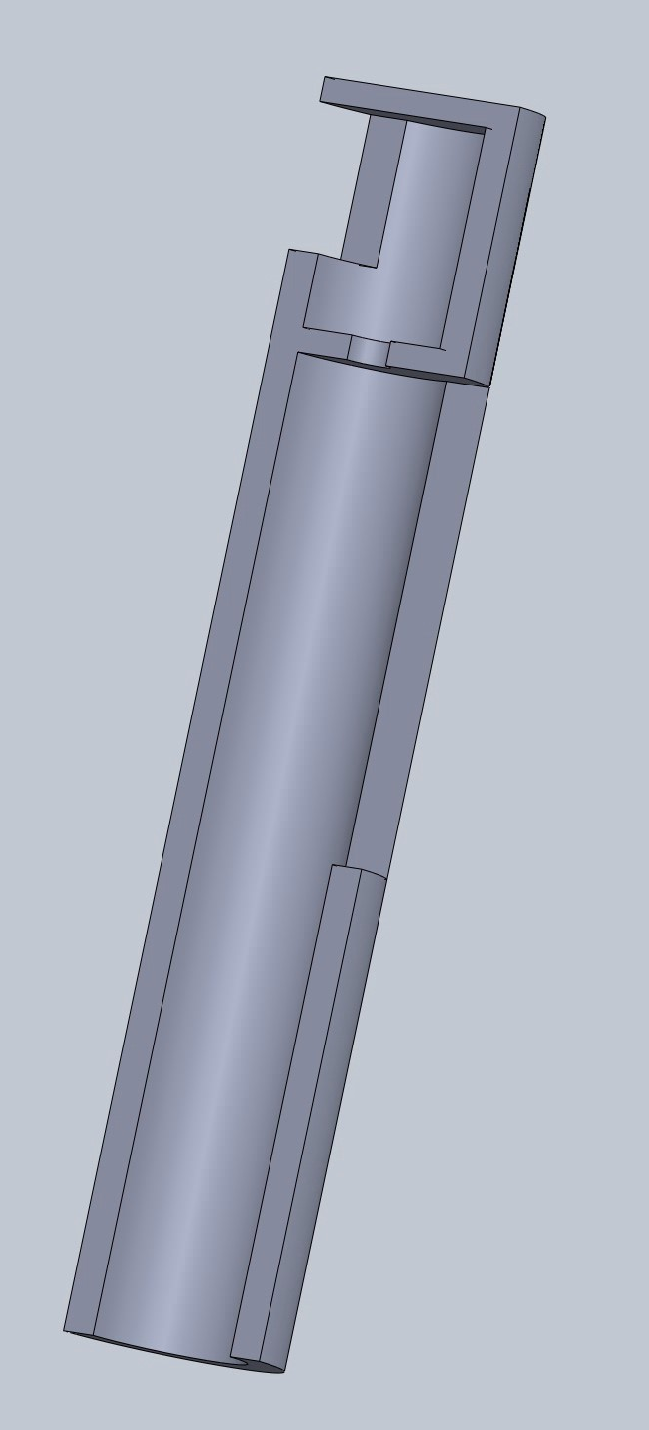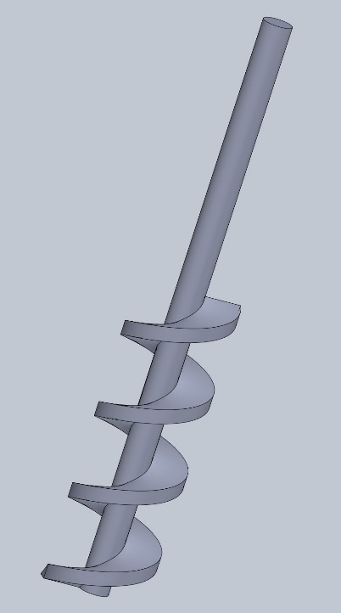
Figure 3. Screw and cylinder in SolidWorks

1.3. Buoyancy System
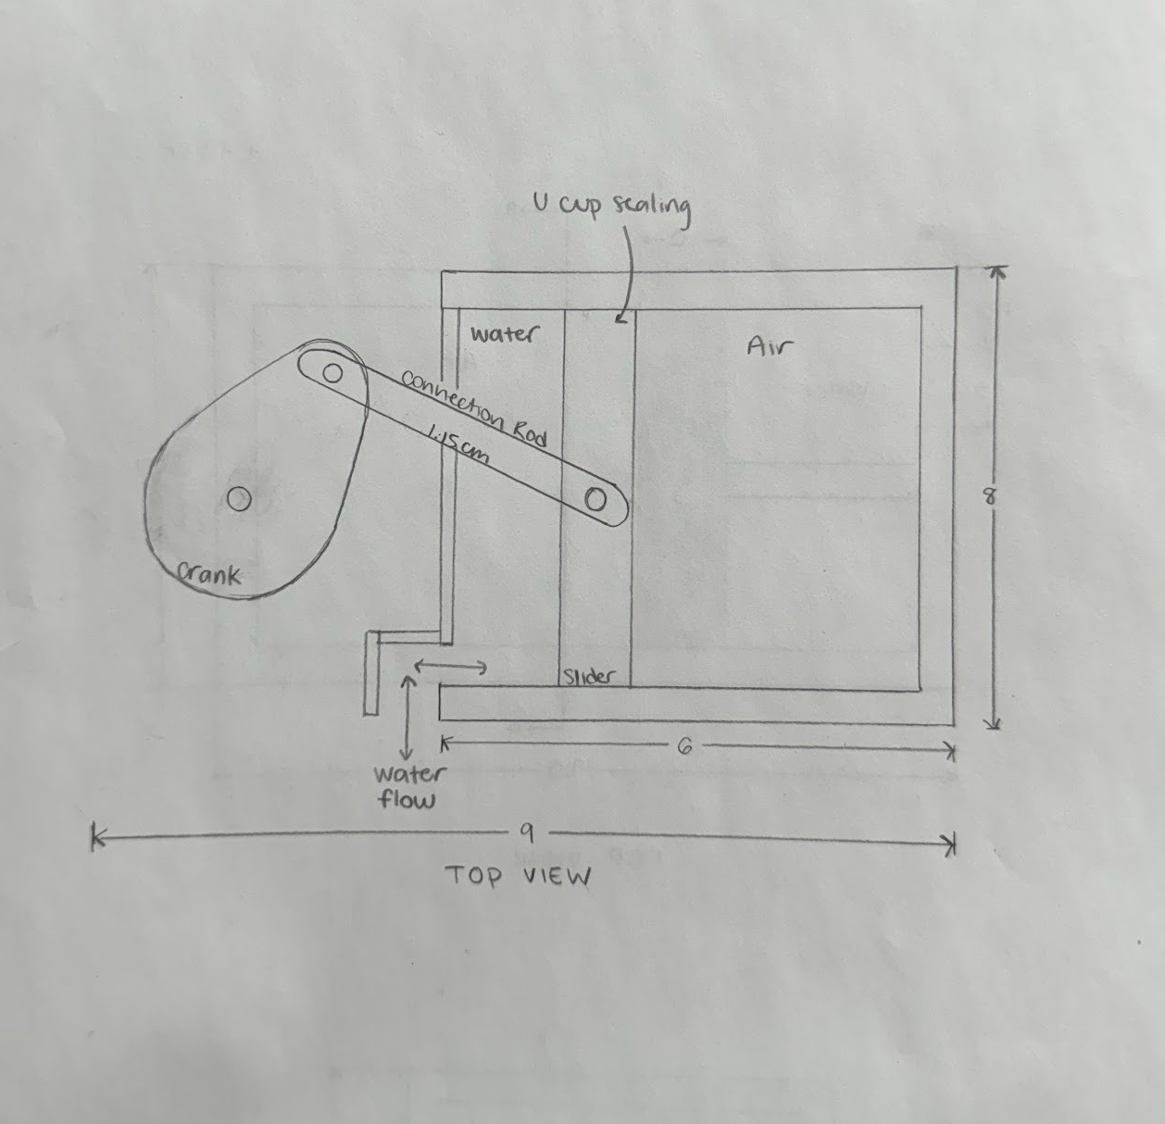
Figure 4. Variable buoyancy system sketch highlighting the rotational to linear motion
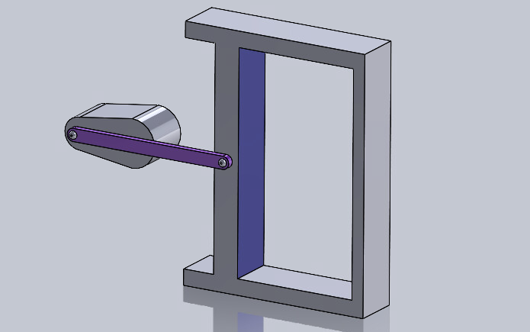

Figure 5. Variable buoyancy system CAD
Last week a buoyancy system was created to ensure the spy crab could have precise vertical control and use minimal energy consumption. The system allows the crab to submerge, float, and ascent/decent. Last week it was undetermined how the piston arm would retract backwards, (decreasing the pressure of the air and pushing the lake water out). For the most recent update a system has been chosen. The piston arm will be driven by a motor with a rotary mechanism. Since there is limited space, the motor will be shared with the motor that drives the legs, this makes sense as the legs and buoyancy system will not be using the motor at the same time. This idea was developed after receiving feedback from Professor Moran, to which he followed by approving the new motor sharing concept. The slider crank mechanism was chosen as it takes rotational motion and converts it to linear motion. The slider and crank can mechanically move the piston back and forth when needed and should be strong enough to displace the water. Other systems that were considered included the scotch yoke and the cam and spring return. However, it was determined that the slider-crank mechanism was the best choice for the buoyancy system since it uses the least amount of material and takes up the least amount of space. It was the most optimal choice since minimizing the weight minimization is crucial for a functional and efficient crab. This mechanism is beneficial as it fits the size limitations of the crab and does not disturb the internal reservoir (like the cam and spring would), which optimizes the amount of air that can be held in the internal reservoir.
The SolidWorks model features the buoyancy system with no lid to highlight the internal workings of the mechanism.
The following update will include finalizing the size and optimizing the mechanism; an assembly will be created to show the motion of the piston arm and the changing size of the internal reservoir to further demonstrate how the buoyancy system is effective.

1.4. Structure and Wear Resistance

The shell of the crab was redesigned to accommodate the internal systems required for the locomotion, buoyancy and sampling mechanisms. The initial shell geometry was modified by increasing the wall thickness to provide additional space for the internal components while also maintaining the “crab-like” form. This change allows for extra clearance for components such as drive shaft, motors, buoyancy systems as well as the sampling mechanism to fit without interfering with the legs. The thicker shell helps improve structural integrity and help seal the motor and any other electrical component from water.
The shell geometry now includes more refined mounting points for the legs and claws to not restrict their motion. To help simplify the overall structure the internal shell was redesigned to secure the motors and supports onto the shell. The claws have also been redesigned into two parts that are connected by a fixed rotational joint.
Material consideration was also taken into account during the shell design. A durable polymer such as HDPE (high density polyethylene) is considered as it has great resistance to corrosion, low density and lightweight. HDPE is mostly used in marine environments which makes it great for the crab shell as it is exposed to the water the longest. As HDPE has these properties it would help the structure from degradation over time while maintaining its strength ad resistance for its internal and external loads.

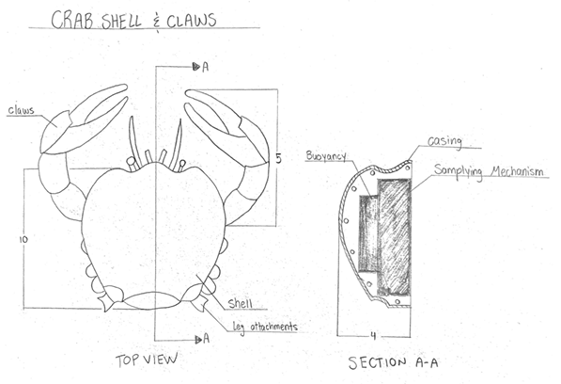
Figure 6. Crab Shell and Claws Sketch

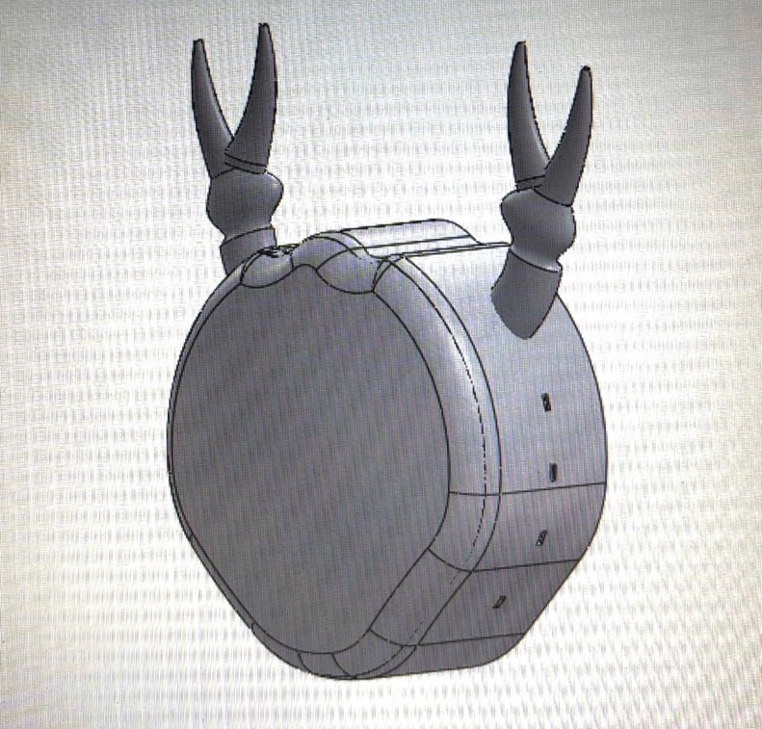

Figure 7. Crab Shell and Claws Design in SolidWorks

1.5. Stability System

The updated friction pad which was previously designed to be a hemispherical shape has changed to be more of an elongated dome. This decision was made after considering the width and spacing of the legs and the leg shell which will later be added. With the hemispherical design, it was found that there was no clearance between each footpad for the legs to pass one another while walking. The elliptical shape was chosen because with this design, we can ensure the same surface area is covered by the pads, but the lateral width would be decreased enough to stop the interference between legs. If the original spherical design was sized down, this may have solved the problem however the contact area would have had to decrease. The ellipse has a width of 2.5 cm and a length of 3.2 cm and the height will be maintained at 1.2 cm.
The new shape still maintains smooth movement and minimal disturbance to the seabed when compared to the initial rectangular design. The measurements of the sleeve in the ball and socket joint for the leg shell to fit in will be finalized once the leg shell is made to determine the correct fit. A screw hole has been added in both the foot pad and linkage for the foot to be able to screw in easily. Next steps will be to incorporate this ellipsoid shape seen in the sketch into the SolidWorks design as well as finalize screw hole and sleeve measurements as well as the sizing of the ball and socket joint with the retaining cap. Spikes will also be added to increase anchoring to the seabed when stationary and increase grip when walking on rocky surfaces.
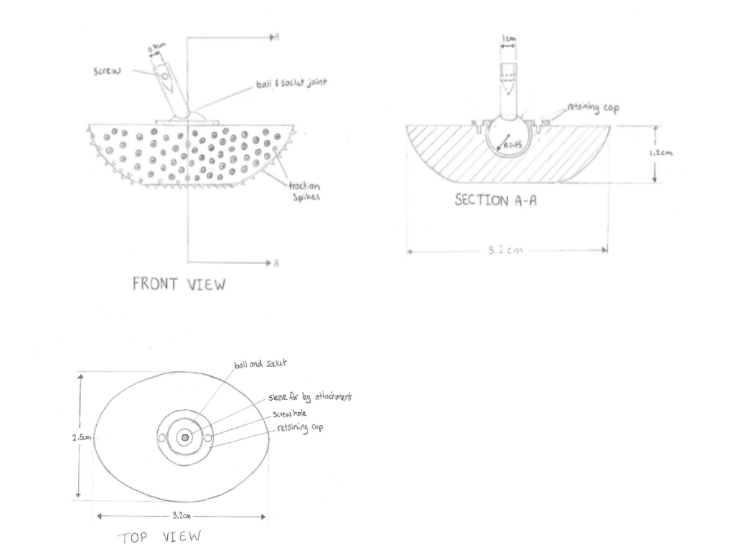
Figure 8. Sketch of elliptical friction foot pad
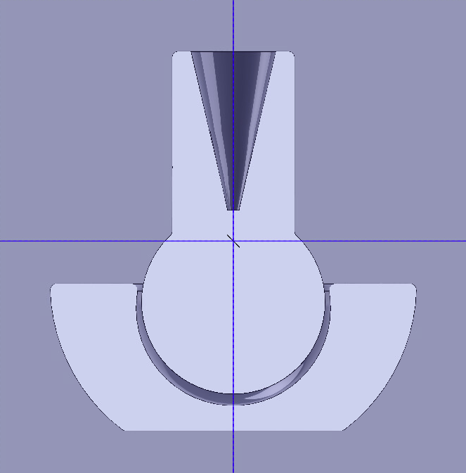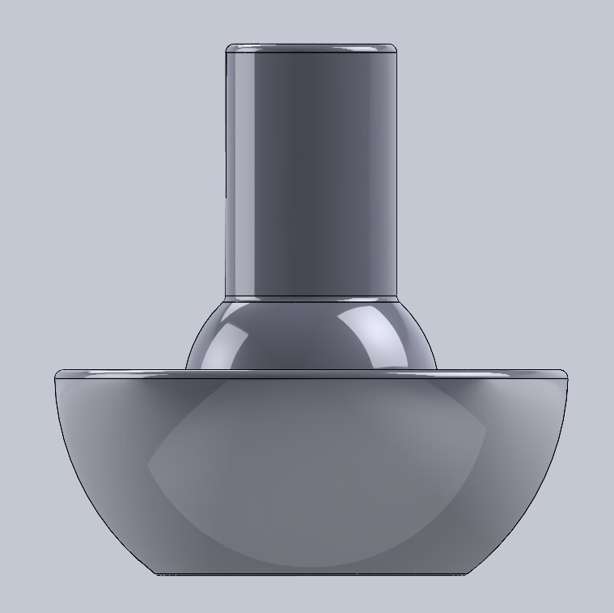
Figure 9. Section and front view of footpad design in SolidWorks

1.6. Assembly
Significant time was spent refining the overall SolidWorks assembly to better represent the crab system. The previous assembly served as a rough conceptual CAD model to help guide us through how the crab looks like when all the subcomponents are mated together. This updated model incorporates more realistic geometry and proportions for the main structural components. The redesign focused on improving the layout of the subsystems within the shell to ensure enough space for the internal components while not interfering with the external components (the legs). The inside of the shell is shown in figure 9 for the “Crab Shell & Claws” sketch to help visualize how the internal space will be used for the components. Although the model is still under development and still must be more detailed, it provides a much clearer representation of how the subsystems will integrate within the overall structure. Developing the updated assembly model also helped identify potential interference and spacing issues between components. This SolidWorks model will still be used as a foundation/ guide for future developments rather than a fleshed-out model of all the connections which will be provided in the following deliverables.
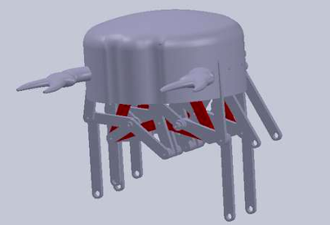
For next steps, a shell will be added to the locomotion linkage as well as the final connection of this shell to the friction footpads. The buoyancy system and sampling mechanism will be mounted within the shell, and all spacing will be finalized. Room for the motors within the shell will also be considered and added.

Figure 10. Crab Assembly in SolidWorks

References

[1] “716-403 – 16mm Brushless Motor,” Precision Microdrives. Accessed: Mar. 15, 2026. [Online]. Available: https://www.precisionmicrodrives.com/product/716-403

Appendix
Figure 12. Sampling Mechanism Gantt Chart
Figure 11. Locomotion Gantt Chart

Figure 13. Buoyancy Gantt Chart

Figure 14. Frame Gantt Chart
Figure 15. Stability Gantt Chart

